How Different are New York & Washington from the Rest of the Country?
Issues in Expanding Eligibility of The September 11th Fund

Summary
From its inception, the Fund has had to make choices about whom to help: who has had the most severe needs, and how directly have they resulted from the events of September 11th? It was clear from the beginning that, with finite resources, not everyone directly or indirectly affected could be assisted. In each instance, the Board has decided how broadly to provide assistance. Thus far, help has been authorized for families of the deceased and injured, for rescue workers, evacuees and witnesses, dislocated residents, workers and school children.
In most cases, the Board opted to help those who were in the immediate area of the attack. In deciding how broadly to provide assistance to the economically dislocated, the Board approved aid for those whose livelihood was physically disrupted by the closing of lower Manhattan or National Airport, but not those who worked elsewhere in New York or in the U.S. Similarly, the Board approved mental health assistance for those who lost a family member and those who were in the area and fled, but not for those who lived or worked elsewhere within New York.
Regardless of these determinations, the Fund is continually urged to help others who were less directly affected. Unemployment rose after September 11th, and many people remain out of work. Early studies (some paid for by The September 11th Fund) report that people throughout New York evidence symptoms of post-traumatic stress. The Fund has been asked to consider whether its programs could expand to include:
- The economically displaced in the New York and Washington, DC, regions who fall outside of the Fund’s catchment area; and
- Residents of New York City or the region (outside the WTC area) who may need mental health services.
The staff has, for several months, been analyzing such proposals. We are not recommending any expansion at this time.
- With regard to economic dislocation, it appears that New York and Washington did not suffer more than many other cities.
- With regard to mental health needs, it may be true that New Yorkers are likelier than others to suffer post-traumatic stress disorder. There are as yet no national studies, but studies of Oklahoma City and other disasters suggest that those closer to the site of a disaster are likelier to be affected. It is unclear how strong this effect may be. We would recommend revisiting the issue in the fall, when more information may be available and we will know whether the Fund has resources remaining.

Criteria: When Should the Fund Expand its programs?
To justify expansion of eligibility for assistance to NY/DC residents beyond those the Board has already decided to help, there would seem to be two tests:
Disproportionate Damage: Is it clear that the impact of September 11th – either in economic or psychological terms – was more significant in New York and Washington, DC, than in other regions? If not, it would be hard to justify providing help to New Yorkers or Washingtonians without enabling equivalent help for, say, residents of San Francisco or Chicago.
Adequate Resources: Are there adequate funds remaining to provide services to this expanded class of eligible beneficiaries after meeting the needs of those more directly affected?
Presently, it is not possible to assess whether the Fund can expand its eligibility for services, since it is unclear whether sufficient resources will remain after the Ongoing Recovery Program has been implemented for families of the deceased and injured, and already-eligible residents and workers. Nonetheless, Fund staff continue to investigate whether residents of New York and Washington, DC metro areas have in fact suffered disproportionately as a result of the events of September 11th.

Economic Dislocation

Original Eligibility Definition for Economic Dislocation
In the immediate aftermath of the attacks, the Fund provided assistance to family members of the deceased, the injured, and dislocated residents and workers. Displaced workers were defined as the population who lost their jobs, between September 11th and January 11th, who worked below Canal Street. The Board contended that this geographic criterion was a natural and logical one, given the federal cordon that prohibited vehicular and pedestrian access to the area below Canal Street for several weeks. Thousands of residents who supported local retail establishments were themselves displaced, and many of these residents also worked in the area and became unemployed. It is estimated that 35,000-45,000 people in this catchment area lost their jobs or experienced substantial income reduction. The Fund distributed more than $115 million in cash assistance to these individuals.
At the February 13th meeting, the Board reviewed this displaced worker definition and added Chinatown and National Airport as areas of eligibility. Board and staff agreed that Chinatown, including the portion of Chinatown north of Canal Street, suffered economic hardship following the September 11th attacks that was clearly a result of reduced access rather than a general economic slowdown. This was particularly true because police barriers blocked commercial access to many garment manufacturers above Canal Street, many of which were the largest employers in Chinatown. Similarly, the documented job loss at National Airport in Washington, DC – also an area that was closed by federal fiat for several weeks and suffered an estimated 10,000 layoffs – was grounds for inclusion in the Fund’s Ongoing Recovery Program. Again, the Board defined dislocation in terms of direct economic impact as a result of physical disruption to regular business.
Where physical disruption did not occur, the Board elected not to expand eligibility. The Board decided that workers in the tourism and hospitality industries above Canal Street and outside New York who suffered job loss in the wake of September 11th would not receive Fund assistance. Although tourism halted, travel was cut back, and unemployment rose, it was not clear whether these effects were September 11th-specific or related to the larger recession. There was also no data to assess whether airline or hospitality workers in New York had suffered more than their counterparts in other locations. Any notion of equity would have made job loss in other tourist and airline centers – Las Vegas, Orlando, Dallas, Honolulu, Seattle, Wichita, Washington, DC (to name a few) – legitimately eligible for assistance. Given the sheer numbers of this group, providing assistance to all would have required more resources than were available in the Fund. The Board therefore adhered to its direct economic impact criteria.
Nevertheless, the Fund continues to be pressed to consider expansion of eligibility to include others whose lives were significantly disrupted by the events of September 11th and who could benefit from some or all of the Fund’s case management, mental health, job training, health, legal or financial benefits. Some advocates have proposed providing services to anyone who can substantiate September 11th related dislocation in the New York and DC metro areas, since these cities, they argue, were the centers of the attacks.

Analysis of Post-9/11 Economic Dislocation in New York, DC and Elsewhere
For this reason, staff analyzed changes in post September 11th unemployment in several major U.S. metro areas to determine (1) whether the effects were substantial, and (2) whether unemployment was more severe in New York and Washington, DC, than elsewhere. The analysis took the form of multivariate regression comparing changes in unemployment rates in the six months after September 11th to those for comparable periods in earlier years, correcting for overall national trends in unemployment.
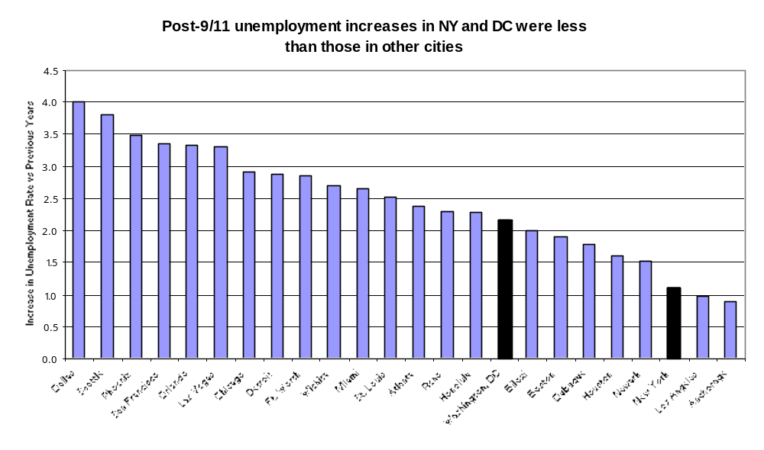The data suggest that indeed, unemployment rose substantially nationwide after September 11th, particularly in cities with significant tourism, hotel, and airline industries.
However, it is also clear that increases in unemployment were much more significant elsewhere: New York ranks only 22 (DC ranked 16), behind Dallas, Seattle, Las Vegas, Chicago, Wichita, Honolulu and several other cities where tourism and the airline industry factor significantly into the local economy. Therefore, preferencing workers above Canal Street over those in other affected cities for employment assistance could be problematic for the Fund.

Mental Health Effects
The staff also sought out comparable mental health information on a national basis, which would make possible a similar analysis. After a great deal of staff investigation, we found no studies yet completed that collected any measures on a nationwide basis.
However, there are some studies, either local in nature or covering other disasters, that examine the relationship between psychological effects and geographical proximity. Reasoning by analogy, it may be true that those who lived closer to the WTC and Pentagon might be suffering disproportionate psychological distress. We are not sure that these studies, alone, provide the basis for a confident judgment, but want to make sure the Board knows about them and that we are continuing to watch the issue. More complete and relevant information may be available in the fall, after other studies are complete, and when the Fund will also have a clearer sense of its remaining resources.

Information from Other Disaster Studies
In general, the studies report that a disaster’s impact on a person’s emotional well being does correlate to some extent to his/her proximity to the site. The strength of the results, however, varies considerably.
- A study which compared the incidence of Post Traumatic Stress Disorder in two Manhattan locations one to two months after the attacks found that 20% of the population south of Canal Street experienced PTSD, compared with 6.8% of the population between Canal Street and 110th Street.
- A second study compared populations in Oklahoma City with those in a control city a few months and then 18 months after the bombing of the Federal Building. Stress was twice as prevalent in Oklahoma City and nightmares/bad dreams were almost three times as prevalent. Here again, both populations showed a decrease in symptoms after a year, but the levels stayed almost twice as high in Oklahoma City as in the control city.
- A third study looked at mental health impacts after 6 months in Australian populations following an earthquake which caused death and property damage. 18.3% of those close to the site showed evidence of Post Traumatic Stress Syndrome, vs 2% for those further away.
- A public opinion survey in New Jersey compared the responses of those living within 30 miles of Ground Zero with those in another segment 70 to 150 miles away. Six months after the attacks, 42% of those closer in continued to worry about a future attack and feel that “life had not returned to normal”, versus 31% in the group further out. Both groups showed less fear as time passed, but the symptoms subsided more quickly in the farther population.
These studies show differences in psychological effects between geographically near and distant populations. However, it is unclear how strong this distinction will be for September 11th, because so many Americans experienced it as an attack on the entire nation. The geographical differences thus far do not approach the level found in Australia after the earthquake.
Mental health experts contend that emotional distress is as likely to worsen with time as it is to mitigate. The direct evidence of any prolonged psychological impacts of the September 11th attacks is not yet available. We will continue to watch the situation to see whether identifiable separate needs arise.

